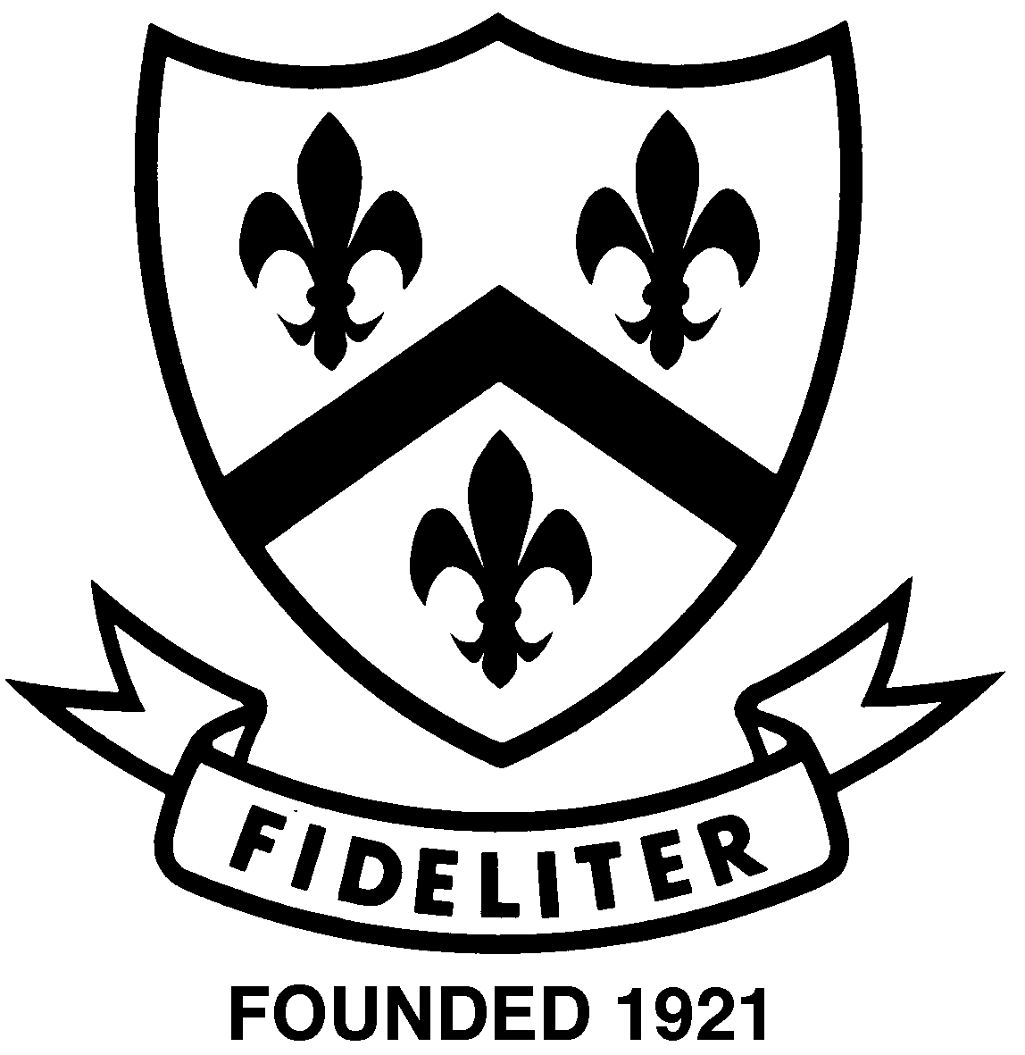

Year 12 Chemistry
In-class assignment: Organic 2010

Name: ___________________________

Please answer the multiple choice questions on the answer key provided below:

1 | A | B | C | D | E
2 | A | B | C | D | E
3 | A | B | C | D | E
4 | A | B | C | D | E
5 | A | B | C | D
6 | A | B | C | D
7 | A | B | C | D | E
8 | A | B | C | D | E
9 | A | B | C | D | E
10 | A | B | C | D | E

 | Mark | Out of
Part One |  | 10
Part Two |  | 20
Part Three |  | 10
Total |  | 40

Part One : Multiple Choice (10 questions; 10 marks)
Please answer these questions on the separate multiple choice answer sheet provided.

- Which one of the following sets of formulae contains only the molecular formulae of saturated chain hydrocarbons?
- C₂H₆, C₄H₈, C₆H₁₀
- C₂H₆, C₄H₁₀, C₆H₁₂
- C₂H₆, C₅H₁₂, C₈H₁₈
- C₂H₆, C₆H₆, C₆H₁₄
- C₂H₄, CH₃CHO, CH₃COOH

- Methyl salicylate, which is commonly found in rubbing liniments, has the formula shown below:

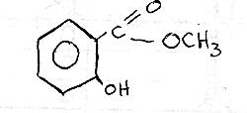

Which functional groups are present in methyl salicylate?
- One alcohol and one ester
- One alcohol and one ketone
- One acid and one ketone
- One acid and one aldehye
- One ether, one ketone and one alcohol

- Which of the following compounds does NOT exhibit geometrical (cis-trans) isomerism?
  - CH₃CH₂CH=CCl₂
  - CH₃ClC=CClCH₃
  - CHCl=CHCl
  - CH₃CH=CHCH₃
  - CH₃CH₂ClC=CCICH₃

- Hexane will not dissolve in water because:
  - There is no chemical reaction between hexane and water.
  - Hexane cannot form hydrogen bonds with water.
  - The intermolecular forces within the two liquids are weak.
  - The hexane molecule is larger than the water molecule.
  - Hexane and water are made of different chemical elements.

- The correct order of increasing boiling points for the substances propane, ethanol, 1, 1-dichloropropane, methane is:
  - Propane < ethanol < 1, 1-dichloropropane < methane
  - Methane < ethanol < 1, 1-dichloropropane < propane
  - Methane < propane < ethanol < 1, 1-dichloropropane
  - Methane < propane < 1, 1-dichloropropane < ethanol

- Which statement is FALSE concerning the compound with the structure CH₃CH₂CH₂COOH?
  - Its name is propanoic acid
  - It can be formed by dichromate oxidisation of a primary alcohol
  - It is a weaker acid than hydrochloric acid
  - It reacts with propanol to form propyl butanoate

- Which one of the following procedures would enable you to distinguish between 1- butanol and 2-methyl-2-propanol?
  - Shaking the compound with acetic acid (ethanoic acid) and observing whether the two liquids mix.
  - Shaking the compound with ethanol and observing whether the two liquids mix.
  - Shaking the compound with bromine water and observing whether the orange is decolourised.
  - Warming the compound with a solution containing sodium dichromate and sulfuric acid and observing whether the orange colour changes to deep green.
  - None of the above, because both compounds are alcohols.

- Which of the following are tertiary alcohols?

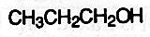
I III
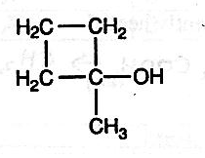
II IV
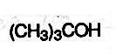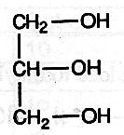
- I and II only
- I, II and IV only
- II and IV only
- II, III and IV only
- All four alcohols

- Which of the following would act as a detergent?

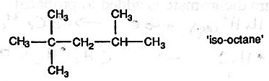

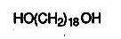

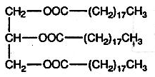

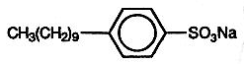

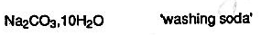

- Which of the following compounds can be oxidised to form a ketone?
  - CH₃OH
  - CH₃CH₂OH
  - CH₃CH₂CH₂OH
  - CH₃CH₂CHOHCH₃
  - (CH₃)₃COH

Part Two: Written (3 questions; 18 marks)
1. Write balanced ionic equations for the following reactions (if a reaction does occur)

- ethanol is burnt in air

____________________________________________________________________

- propanol is mixed with butanoic acid and gently heated

____________________________________________________________________

- water is added to butyl ethanoate

____________________________________________________________________

- bromine water is added to ethene

____________________________________________________________________

- a solution of potassium dichromate is added to propanal

_____________________________________________________________________
(10 marks)

2. Name the following structures
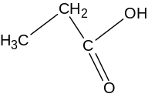a)
_________________________

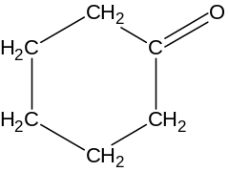b) ________________________

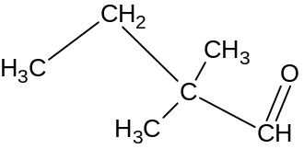c)
__________________________

d)

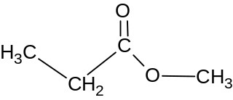 ________________________
(4 marks)

3. Rank the following substances in order of increasing solubility in water and give a reason for your ranking: ethanol, pentanol, ethanal and ethane.

_______________________________________________________________________

_______________________________________________________________________

_______________________________________________________________________

_______________________________________________________________________

_______________________________________________________________________

_______________________________________________________________________

_______________________________________________________________________

_______________________________________________________________________

_______________________________________________________________________

_______________________________________________________________________

_______________________________________________________________________

_______________________________________________________________________
(4 marks)
4. What is an alpha amino acid? Draw a labelled structure to illustrate your answer.

(2 marks)
Part Three: Calculations (1 question; 10 marks)
1. An unknown organic compound Z contains only the elements carbon, hydrogen and oxygen.
When 1.200g of Z is completely burned in an excess of oxygen the products are found to be 1.440g of water and 1.994L of carbon dioxide measured at 127ºC and 100kPa.
When a further 1.200g of the compound is vapourised the vapour produced is found to be 664.8mL at 127ºC and 100kPa.

- Determine the empirical formula of Z

(5 marks)
- Determine the molar mass and hence the molecular formula of Z.

(3 marks)
- Given that Z will react with sodium metal to produce hydrogen gas, draw and name two possible structures for Z.

(2 marks)

Year 12 Chemistry
In-class assignment: Organic 2006 – ANSWERS

Multiple Choice
1. c 2. a 3. a 4. b 5. d 6. a 7. d 8. a 9. d 10. d

Part Two
  - a) ethanol burnt in air
CH₃CH₂OH _{(aq)} + 3O_{2(g)} →2 CO_{2(g)} + 3H₂O_{(l)}

b) propanol is mixed with butanoic acid and gently heated
CH₃CH₂CH₂OH_{(aq)} + CH₃CH₂CH₂COOH_{(aq)} →CH₃CH₂CH₂COOCH₂CH₂CH_{3(aq)} + H₂O_{(l)}

c) H₂O_{(l)} + CH₃COOCH₂CH₂CH₂CH_{3(aq)} → CH₃COOH_{(aq)} + CH₃CH₂CH₂CH₂OH_{(aq)}

d) Br₂(aq) + CH₂CH₂ → CH₂BrCH₂Br

e) Cr₂O₇²⁻_{(aq)} + 14H⁺_{(aq)} + 6e⁻ → 2Cr³⁺_{(aq)} + 7H₂O_{(l)}
CH₃CH₂CHO + H₂O → CH₃CH₂COOH + 2H⁺ + 2e⁻ ) x 3
____________________________________________________________
3CH₃CH₂CHO + 8H⁺_{(aq)} + Cr₂O₇²⁻_{(aq)} → 2Cr³⁺_{(aq)} + 3CH₃CH₂COOH + 4H₂O_{(l)}

  - a) propanoic acid
b) cyclohexanone
c) 2,2-dimethylbutanal
d) methyl propanoate
(4 marks)
3 ♥ ethane – has only dispersion forces
♥ ethanal – is polar due to carbonyl group, possible some weaker H-bonding between lone pairs of electrons on its carbonyl group and the positive charge on the water molecule
♥ pentanol – has H- bonding but longer non-polar hydrocarbon chain lessens magnitude of solute –solvent interaction
♥ ethanol – has H-bonding and can have solute-solvent H-bonding with H₂O
(4 marks)
4. an alpha amino acid is a molecule that has the amino (NH2) and carboxylic acid (COOH) functional groups attached to the same carbon atom
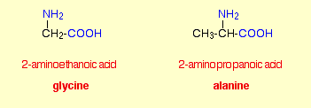
(2 marks)
Part Three: Calculations
1. a)CHO + O₂ → CO₂ + H₂O
1.200g v= 1.994L 1.440g

 | C | H | O
mass | 0.7200g | 2.016/18.016 ) x 1.440  =0.1611 | 1.200-(0.7200+0.1611)  =0.3189
moles | PV = nRT  (100)(1.994) = n(8.315)(400)  n= 0.05995 | 0.1611/ 1.008  = 0.15986 | 0.3189/16  = 0.0199
ratio | 0.05995/0.0199  = 3 | 0.15986/0.0199  = 8 | 0.0199/0.0199  =1
Therefore empirical formula is C₃H₈O

b) PV =nRT
(100)(0.6648) = n(8.315)(400)
n= 0.019988

n= mass/mass 1 mole
mass 1 mole = 1.200/0.019988 = 60

EF mass is also 60 so the molecular formula is the same as the empirical formula
(3 marks)

c)
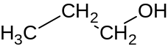 1-propanol

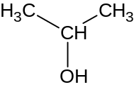 2-propanol (2 marks)

